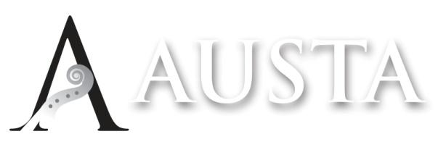

The Annual General Meeting of the Australian Strings Association Limited (AUSTA) will be held on Wednesday November 25 at 8.00 pm Australian Eastern Daylight Time.

Notice is hereby given that the 2026 Annual General Meeting will be held online via Zoom on Wednesday November 25 at 8:00 pm AEDT.

Members who would like to participate should contact Maxine Gatt (AUSTA National Administrator) by email admin@austa.asn.au or phone 0480 841 176 for access to the relevant Zoom links.

The audited financial statements will be made available to members on the website prior to the meeting.

Members who would like to nominate a proxy can use the form below and email it to the National Administrator by Sunday 15th November.

Meeting Agenda:
- President’s Welcome
- Minutes of the 2025 AGM
- Reports:
  - President
  - Treasurer
  - Chapter Presidents
  - Stringendo
- Acceptance of Financial Report and Audit
- Ratification of Board of Directors
- Confirmation of Charity Status
- Other Business

AUSTA Ltd – Proxy Nomination Form

I/We ........................................................................... being a member/members of the Australian Strings
(Member/s Name)
Association (AUSTA) hereby appoint ............................................................................................................. of
(Proxy Name)
..................................................................... or, in his or her absence, ......................................................... of
(Proxy Address) (Proxy Name)
..................................................................... as my/our proxy to vote for me/us on my/our behalf at the meeting
(Proxy Address)
of the Company’s members of the Company to be held on the 25th day of November 2026, and at any adjournment of that meeting.

SIGNED this ................ day of ....................................................., 2026

