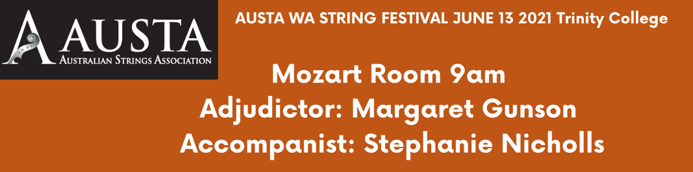

Chloe Leung Petite école de la mélodie, Op. 123 no. 15, Etude - Dancla
Yi-Heng Tsai Prelude from Te Deum H 146 - Charpentier
Kaitlyn Chen Donkey Doodle - William Kroll
Navkishori Rathod Beetle's boots
Lucien Zhang and Jack Peppercorn Arirang- Korean Trad. arr. Han-Ki Kim
AJ Dowling’s ng Blast off - Mary Cohen
Nina Januschka Chinese Lanterns - Hugh Colledge
Charlotte Lee Sonata G major - Antonio Vandini
Eva Chi La Preciseuse - Marin Marais
Samansha Singh A string Concerto - Berger
Ishaan Dhanak Go tell Aunt Rhody
Laurence Mitchell TBC
Erica Wong Danse Espagnole - Manuel D. Falla
Ami Tang Long Long Ago
Tia Tang Twinkle Theme
Jayden Li Busy Busy Stop Stop Twinkles
Yi-Zhen Tsai Plesiosaurs - Caroline Lumsden & Pamela Wedgewood
Yi-Jin Tsai Praeludium and Allegro - Fritz Kreisler

