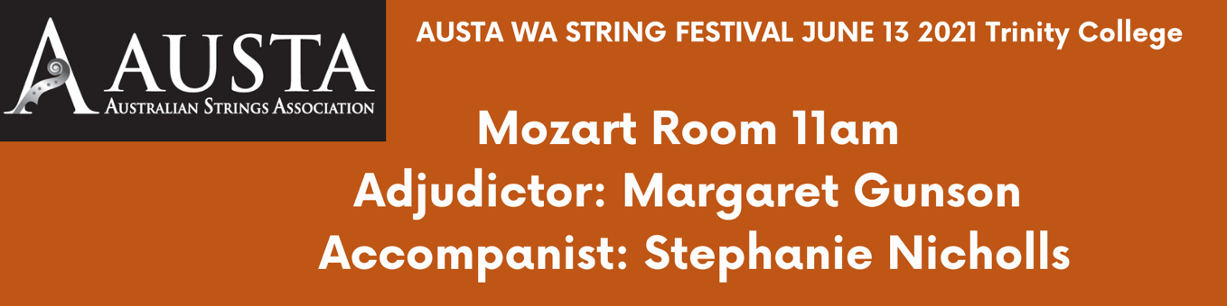

Alex Grove First Base - Louise Chamberlain

Joanna Wang Elegy - Bruce Lawrence

Atsu Tsuru Sonata for Violin Solo No. 1 in G Minor, BWV 1001: III. Siciliana - J. S. Bach

Trio Fantastique (Uma Sky Fisher, Ari Fisher & Jordan Scott)
Piano Trio Miniatures, Set 3, Valse Russe & Hornpipe - Frank Bridge

Lakshika Fernando Swing and Swang – Bailey

Ver Son Goh Berceuse (David Stone)

Noah Wang Berceuse - Aleksandr Aleksandrovich II'inskiy

Natasha Foo Romance – Henryk Wieniawski

Carol Lam The Butterfly Lovers Violin Concerto

Stacey Shan Gavotte – David Popper

Xinnui Qiu Minuet no. 2

Ari Fisher Tarantella op. 23 – William Henry Squire

