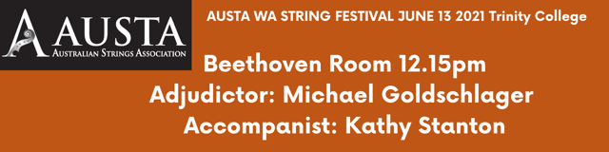

Sam Rowntree Tarantella - W.H. Squire

Liam Nelson The Ceilidh - Katherine and Hugh Colledge

Lillian Duarte La Cinquitaine - Gabriel Marie

Romana Butcher
“The mocking bird” and “Stamping dance" - Kathy and David Blackwell

Ameesha Brien Jupiter - Holst

Dhari Kalli Kolomeika - Mihály Hajdu

Zachary Madan Ave Maria - Bach-Gounod

Ethan Ding Tarantella - Squire

Emerson Ding Strassvogel - Gretchaninoff

Iman Clarke Violin concerto no.2, 3rd movement - Seitz

