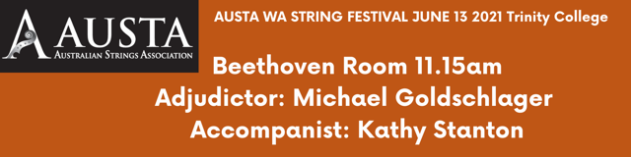

Lillian Tyter Concerto - Thomas Gregory

Sybil Upton Sprint Finish - Kathy & David Blackwell

Jillian Morris That’s how it goes - Kathy & David Blackwell

Delphie Zhang Gavotte - Gossec

Sophia Zheng The Hundred Pipers - Carolina Nairne

Adam Ioannou Start the Show - Kathy & David Blackwell

Zhuo Yi Tan Cossack Dance - Timothy & Natasha Kraemer

Lucas Allmark Elegy - Bruce Lawrence

Charly Willers & Neve Arthy Happy Go Lucky - David & Kathy Blackwell

Alma Takano Sarabande in G Minor - Carl Bohm

Emma Ou Melodie - Tchaikovsky

Hudson Ioannou Arpeggio Bounce - Loreta Fin

Olivia Zhao Magyaros and A kis fecsegő - István Szelényi

Gillian Lowe and Nicole Jones Rigaudon - Henry Purcell

Kobe Wu Siciliano and Allegro Assai - Ferdinand Küchler

Viola Trio: Jessica Casey, Olivia Zhao, Kobe Wu
Two Finales – Saint Saëns and Brahms; Elunchun Folk Song – Trad. Chinese arr. Wang

