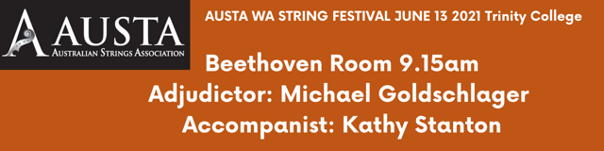

Elyssa Nicolay Arpeggio Bounce - Loretta Fin

Eva Mellor Concertino op.15 3rd movement - Ferdinand Küchler

Chanel Webb Helter skelter - Mary Cohen

Luca Heng Prelude in G major – J.S. Bach

Tanya Tham Russian Fantasy No. 2 - Leo Portnoff

Samantha Chan Over the Rainbow - Harold Arlen

Helena Yang Wild Honey - Louise Chamberlain

Serene Hu Patrick's Reel - Kathy and David Blackwell

Leonardo Parise Concerto No.5 in D Major,Op.22,1st Mvt - Seitz

Marina Nakagawa Gavotte - J.S. Bach

Emily Nakagawa Minuet No. 3 - J.S.Bach

Kylie Zhang Sicilienne op.78 - Faure, arr. Weretka

Lily Sawyer Open Sesame - Edward Huws Jones

Lizzy Marsh Sonata in A major for cello & piano, 3rd Movement, Recitativo & Fantasia - C. Franck

Yasmin Omran Symphonie Espagnole 1st movement - Eduard Lalo

